Project Design Phase-II

Data Flow Diagram & User Stories

|  |  |
| --- | --- |
| Team ID | PNT2022TMID45949 |
| Project Name | Emerging methods for early detection of forest fires |
| Maximum Marks | 4 Marks |

# Data Flow Diagrams:

A Data Flow Diagram (DFD) is a traditional visual representation of the information flows within a system. A neat and clear DFD can depict the right amount of the system requirement graphically. It shows how data enters and leaves the system, what changes the information, and where data is stored.

Example: DFD Level 0 (Industry Standard)

# Example: [(Simplified)](https://developer.ibm.com/patterns/visualize-unstructured-text/)

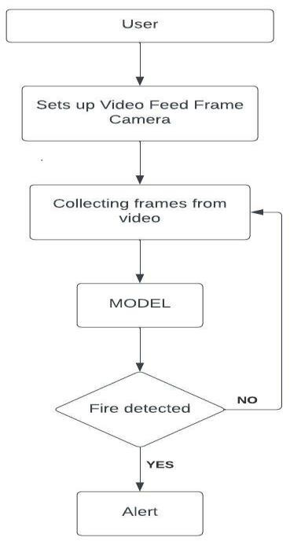

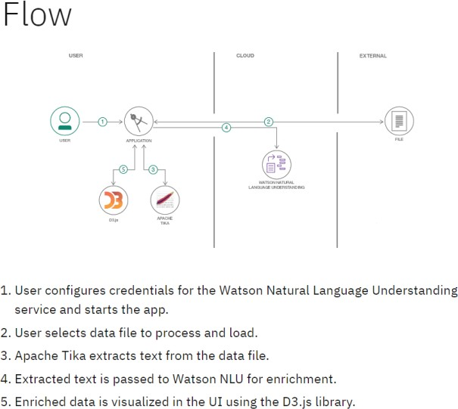

**User Stories**

Use the below template to list all the user stories for the product.

|  |  |  |  |  |  |  |
| --- | --- | --- | --- | --- | --- | --- |
| **User Type** | **Functional**  **Requirement (Epic)** | **User Story Number** | **User Story / Task** | **Acceptance criteria** | **Priority** | **Release** |
| Customer (Mobile user) | Registration | USN-1 | As a user, I can register for the application by entering my email, password, and confirming my password. | I can access my account / dashboard | High | Sprint-1 |
|  |  | USN-2 | As a user, I will receive confirmation email once I have registered for the application | I can receive confirmation email & click confirm | High | Sprint-1 |
|  |  | USN-3 | As a user, I can register for the application through Facebook | I can register & access the dashboard with Facebook Login | high | Sprint-2 |
|  |  | USN-4 | As a user, I can register for the application through Gmail |  | Low | Sprint-1 |
|  | Login | USN-1 | As a user, I can log into the application by entering email & password | They can access the details and dashboard | High | Sprint-1 |
| Customer (Web user) | Registration | USN-3 | Login into executive portal to help the user | Help in accessing the moment and the acess | High | Sprint-1 |
| Customer Care Executive | Help dashboard | USN-2 | Can provide the necessary details of help through desired way like emails,mobiles and SMS |  | Medium | Sprint-1 |
| Administrator | User account control | USN-4 | The person who is responsible for the website control and other management  activities | Provides support to forest fire predection | High | Sprint-1 |